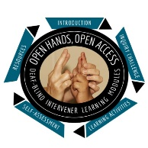
Open Hands, Open Access Deaf-Blind Intervener Learning Modules
Module: Orientation and Mobility in Everyday Routines

Travel Video Analysis Report Form

Instructions
Name:
Date:
As you watch Junior’s active travel video, use this form to record how each of the principles of an effective travel routine are addressed. If you do not feel a principle is addressed explain why and what you would have done differently.
Principle 1: An effective travel routine is purposeful and meaningful.

Principle 2: An effective travel routine has a beginning, middle, and end.

Principle 3: An effective travel routine reaches for increased levels of independence over time.

Principle 4: An effective travel routine encourages exploration and tactual contact with the environment.

Principle 5: An effective travel routine emphasizes environmental patterns.

Principle 6: An effective travel routine helps a student access critical information within a route.

Principle 7: An effective travel routine practices formal mobility techniques correctly.

Principle 8: An effective travel routine reinforces orientation skills.

Principle 9: An effective travel routine embraces opportunities to practice travel-related communication skills.

Principle 10: An effective travel routine promotes decision-making.

