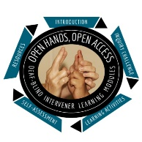
Open Hands, Open Access Deaf-Blind Intervener Learning Modules
Module: Calendars

Intervener Journal
This journal is a way for you to note ideas or thoughts that you have as you proceed through the module. It also includes some questions that you will be directed to from specific sections of the module.
Before you use this journal, save a copy to your computer or other location.
Name:
Date:

Inquiry Challenge Questions
- How do you use calendars in your own life? What purpose do they serve? What would your life be like if you did not have a calendar?
- Now think about a student who is deaf-blind and has limited language skills. Would the student be able to use a calendar? What purpose would it serve for him?

Revisiting the Inquiry Challenge
Review your answers to the inquiry challenge questions above. Has your perspective on the term “calendar” changed? How would you answer the questions in #2 above now that you have completed this module?

