Calendars and Communication

This reading is an excerpt is from Chapter 1 of the book Calendars for Students with Multiple Impairments Including Deafblindness, by Robbie Blaha, Texas School for the Blind and Visually Impaired, 2001.
The development of communication is seriously affected by the combined loss of vision and hearing. As a result, students with deafblindness have a great need for strong communication programming. Calendar systems play an important role in supporting and expanding students’ communication. To show the relationship between communication and calendar, the following section provides a brief overview of four areas which are important to include in students’ communication plans.
- Communication forms/symbols
- Communicative functions
- Topic development
- Social conversations
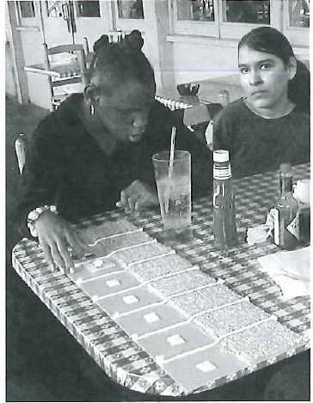
Calendars can support a variety of communicative functions in a number of environments.
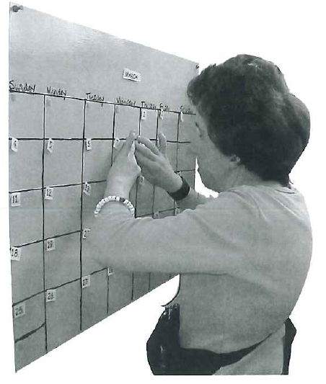
Braille notes help this student organize a month’s activities.

Communicative Form or How We Communicate

Typical Communicators

Possess an array of recognizable forms: speech, pictures, written words, gestures, pointing.
Communication forms of symbols can range from concrete to very abstract in nature. We don’t quit using the forms we know when we learn new ones. Even though we can read print, at times we use a simple gesture or point to covey information.

Use both static and dynamic forms throughout the day.
Some forms are tangible or static because they “stay put.” Static forms are important because one can examine and refer to them as long or as often as needed. Static forms are either three dimensional (i.e., object, tactile symbol, Braille) or two dimensional (i.e., drawing, photograph, printed word).
Dynamic forms are essential to us because they provide spontaneous, “on the spot” information and assistance. These forms disappear as soon as we produce them. If we want to refer back to the message they conveyed, we have to retrieve it from memory or ask that the information be repeated. Some examples of dynamic forms are spoken words, signs, fingerspelling and gestures.
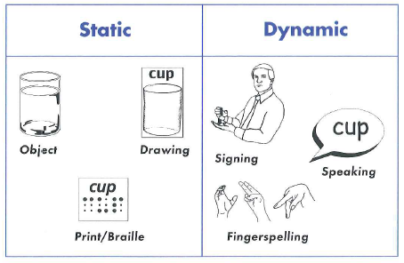

Students with Deafblindness
Note: An individual student may or may not exhibit all of these characteristics.

Have fewer forms than other students their age.
The acquisition of symbols occurs by repeatedly seeing and hearing others use symbols in a meaningful way. This ongoing incidental exposure to symbols is either omitted or severely distorted for students with deafblindness. As a result, many students with deafblindness have acquired fewer forms compared to other students.

Need to be taught concepts represented by forms.
Because of their sensory loss, students with deafblindness may not have an experience base to interpret more abstract forms without careful programming.
For example, when we read the word bird, many images come to mind based on what we have seen and heard. If students have never seen a bird fly, or heard it sing, they have no valid experiences to call upon when shown the word bird. While they may be able to memorize the printed word, this form is too abstract to convey any true understanding of an actual bird. A form that is used without comprehension is called an empty form, which these students are at risk for developing.

Require unique educational modifications and techniques to successfully learn to utilize forms.
Some examples of these are:
- additional time to access and process information in conversations
- materials presented at a particular distance so they can be seen
- coactive signing
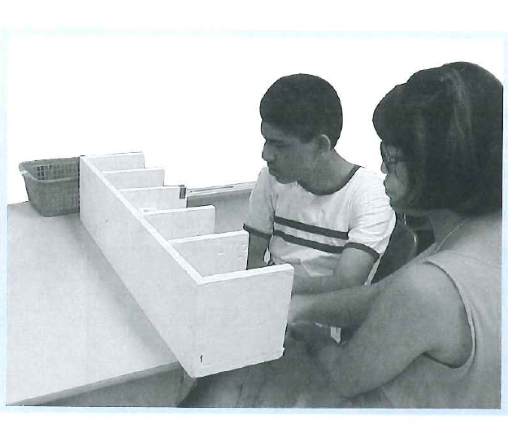
The teacher provides extra time for the student to tactually explore object symbols in the box.
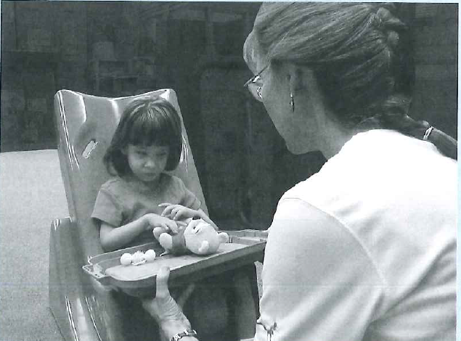
The tray is placed at a level so the symbols can most easily be seen by the student.
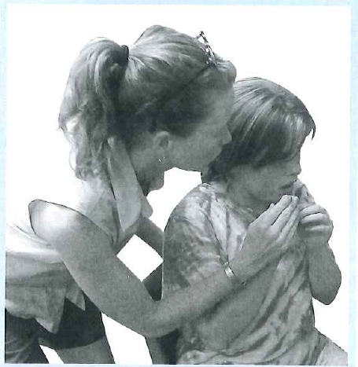
Coactive signing involves guiding the student’s hands to form signs correctly.
Need systematic support to move from concrete to abstract forms.
There is a hierarchy of abstraction when using symbols. Moving from the most concrete to the most abstract symbol for bath time, the order would be:
- for students who use tactual symbols
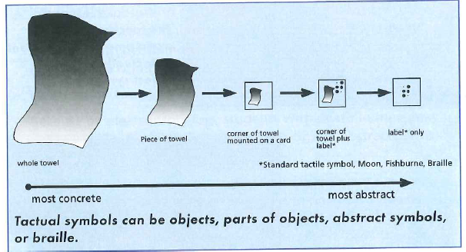
- for students who use visual symbols
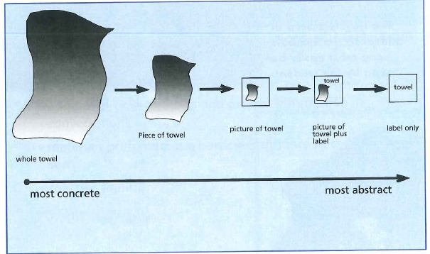
Visual symbols can be traced objects, pictures drawn with students, predrawn pictures, or photographs.

Use different forms receptively and expressively.
A student might understand speech, but be unable to talk and use sign or objects as expressive forms.

Use common as well as specialized forms.
Depending on their sensory skills and needs, students may use typical forms (e.g., pictures, print) as well as specialized forms (e.g., braille, tactile symbols, sign).
For more information about tactual symbols, see Communication: A Guide for Teaching Students with Visual and Multiple Impairments (Hagood, 1997 pp.181 and 232-239).
The following characteristics may be found with typical communicators. They are listed here because these supports for students with deafblindness are very important, but sometimes overlooked.

Rely more heavily on the use of more basic symbols with new information, and more abstract symbols with familiar information.
Is it common to see a mix of symbols (e.g., parts of objects, objects and a few pictures) in a student’s communication system and calendar. The student should add to their existing array of forms without eliminating the earlier ones.
Use a mix of dynamic and static symbols throughout the day.
Communicators should use a combination of static and dynamic forms since one may work better in a situation than another.
For example, if something occurs on the spur of the moment, a dynamic form (like a sign) may be easier and more immediately available than a static form (like a picture) to give the student information.

How Calendar Systems Support the Development and Use of Communicative Forms
- Calendars support the transition from concrete to abstract forms. For example, the teacher may want to move students from an object cue to part of that object mounted on a card. If this new form is presented in the midst of a favorite cooking activity, the student may not notice a change because there are so many other things competing for his attention. When it is introduced in a calendar routine, the simplified and highly structured environment highlights this change. The teacher is able to specifically introduce the association between this new symbol and the cooking activity.
- Calendars tie the symbols of forms (e.g., object cues, pictures) to activities that the child is actually doing. This insures that the symbols have an experiential base behind them and are really understood.
- The symbol or form which represents the activity in the calendar will help bring the activity to mind. The students then have the freedom to talk about things before or after they occur.
- Calendars can individualize the activity so that students have the correct combination of symbols coming in (receptive forms) and going out (expressive forms). Again, this is because the environment is simplified and highly structured.
- Static and dynamic forms can be combined in the calendar dialog. For Example, the teacher may use a toothbrush to represent a toothbrush routine. When presenting the object to a student, the sign for “brush teeth” is used as well as guiding the student’s hands to do the sign herself.
- Calendars can be individualized to accommodate the sensory modifications that a particular student needs to learn forms.

Communicative Function or Why We Communicate

Typical Communicators

Routinely initiate and participate in interactions for specific reasons.
These reasons can be referred to as communicative functions. Some examples are:
- Requesting information, people, actions, objects, etc.
- Rejecting people, actions, or objects
- Responding to questions
- Engaging in social rituals, such as greetings
- Describing/sharing information and experiences

Understand that others may communicate to them for a variety of reasons:
- To give instructions
- To comment
- To provide feedback
- To report on past events
- For playful interactions

Students with Deafblindness
Note: an individual student may or may not exhibit all of these characteristics.
- Are unaware that their communication can exert power over their environment. This results in a lack of intentional requesting and rejecting.
- Have inappropriate forms for rejecting (i.e., challenging behaviors). They may act out because of frustration when presented with something they find unpleasant or confusing.
- May not use communication for purposes other than basic requesting or rejecting.

How Calendar Systems Support the Development and Use of Communicative Function
- Calendars strongly reinforce the power of communication by associating a symbol with an activity. Calendars can give students a motive to communicate. By handing an object to an adult, students cause an activity to happen.
- Calendars support better strategies for rejecting activities than acting out. For example, a student can pull the object from the calendar box and put it in the finished basket instead of lying on the floor to avoid the activity. Some students have been known to hide their calendar symbols, flush them down the toilet, or put them in other students’ calendar boxes as alternative communicative strategies.
- The calendar dialog and routine can have built in opportunities to reject, request, ask questions and comment. Calendar conversations provide the adult with opportunities throughout the day to immediately respond and reinforce the student’s efforts.
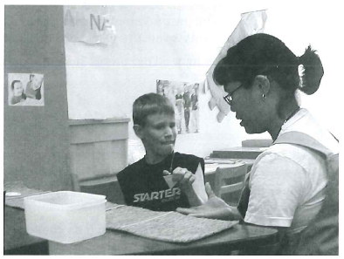
By handing a calendar symbol to an adult, the student causes an activity to happen.

Topic Development or What We Talk About

Typical Communicators
- Have numerous topics to talk about.
- Can easily discuss topics out of context (i.e., before or after they happen).
- Are able to tell when those around them switch to a new topic.
- Organize information around topics so they know the people, locations, objects, actions, and outcomes that are associated with a particular topic.
- Search for topics which are interesting to others to draw them into conversation.
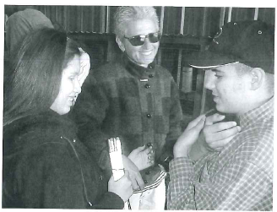
Typical communicators can easily identify the topic being discussed in a conversation.

Students with Deafblindness
Note: An individual student may or may note exhibit all of these characteristics.
- May not have adequate information about topics. The sensory losses significantly reduce and distort a student’s incoming information about the environment. As a result, their experience base is significantly lacking in organized, reliable information.
- Have few topics to talk about.
- Have trouble talking about things before or after they happen. Some students are able to comment on things only in the immediate environment because they lack a way to represent events out of context.
- May have difficulty in establishing or following a topic which is introduced out of the blue.
- May not detect a change to a new topic because they are lacking many cues. Often, subtle cues (e.g., looking at something different, shifting gaze, standing up, taking a breath) indicate a change in topic. Students with a sensory loss may become confused about the course of the conversation.
- May insist that you talk about the same one or two subjects again and again.
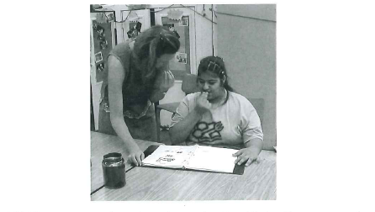
Within a structured routine, the student is able to discuss a meal out of context without becoming confused.

How Calendar Systems Support the Development and Use of Topics
- The topics under discussion at the calendar are what the individual student is most interested in and most likely understands (i.e., daily activities).
- The calendar materials and the special techniques in the routine (e.g., allowing time for examination of a symbol) help the student understand what topic or activity the teacher is talking about and enable her to share a common topic.
- A calendar system supports the expansion of topic discussion by emphasizing new or additional information when it is presented with a familiar calendar symbol (e.g., a party hat is presented with a symbol for store, explaining the purpose of the trip is to get items for a birthday party). This prevents the problem of always saying the same thing about a topic. It is also much easier to understand new bits of information when they relate to a familiar topic. Within a calendar routine, the novelty is enlightening, not overwhelming.
- The structure of the calendar allows you to easily introduce new topics for discussion so that the student’s selection is not so limited. This is useful for a student who may have only have few topics to bring up on her own when she wants to hold someone’s attention.
- Discussion of topics in a calendar dialog supports decontextualization by allowing you to talk about events out of context. For example, the student does not need to be in the kitchen to bring up the topic of a snack. A partner can successfully bring it up by using the symbol which represents the activity.
- If the student is perseverating on a topic, she may be bringing it up to ask for more information. By scheduling the topic in the calendar, you are acknowledging the importance of it to her. By clearly setting aside time to give additional information, you are reducing the need for the student to continuously ask about it.

Social Conversations

Typical of Communicators
- Are motivated to interact with others because they understand the power of communication in gaining things they want or need.
- Know how to locate a partner and gain his/her attention.
- Take turns in a conversation.
- Notice when a communication partner is not understanding and change strategies to clarify communication when this occurs.

Students with Deafblindness
Note: an individual student may or may not exhibit all of these characteristics.
- Can be extremely withdrawn socially. Students may live from the “skin in.” they may fill their time with self-stimulation (e.g., light-gazing, spinning) rather than interactions. By rejecting interactions with others, they are less likely to learn to communicate.
- May not see or hear others interacting because of sensory losses. Consequently, they may lack information on why or how basic interactions take place.
- Have difficulty in distinguishing one person from another based on the limited amount of information they receive. As a result, they may not recognize others if people do not develop specific ways to introduce themselves. Often, more challenged students have a greater number of staff assigned to work with them, which can heighten the confusion.
- Have difficulty searching for or locating a conversational partner.
- May not understand or be motivated to take turns in interactions.
- Require a structured routine with supports and cues in order to communicate. Without them, students may be too confused or anxious to communicate.
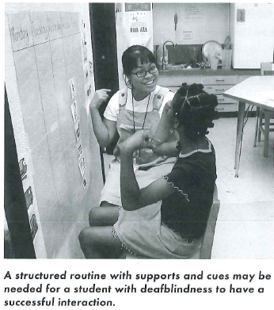
A structured routine with supports and cues may be needed for a student with deafblindness to have a successful interaction.

