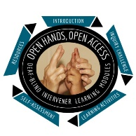
Open Hands, Open Access Deaf-Blind Intervener Learning Modules
Module: Intervener Strategies

Do With, Not For: Assignment

Instructions
Name:
Date:
- Respond to the following questions as you go through the slide presentation called “Learning Activity 1 Assignment (Do With, Not For).”
- Submit your completed assignment sheet.

- Identify 2 things you noticed that were different between the teaching techniques used by the facilitators.

- What is something you noticed about the students’ participation in the activity and what they did or did not do?

- What teachable moments did Facilitator A take advantage of or miss?

- Explain what you saw happening between the interaction of Facilitator B and her student. Did the student seem to know what was expected of her in the task? If yes, how could you tell?

- What teachable moments did Facilitator B take advantage of?

- What factors do you think led to the difference in the length of time it took for the pairs to complete the task?

