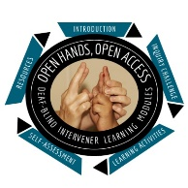
Open Hands, Open Access Deaf-Blind Intervener Learning Modules
Module: An Overview of Deaf-Blindness and Instructional Strategies

Think-Reflect-Pair and Share Activity
Review the notes you’ve made so far in your Intervener Journal and think about what you have learned so far. What mattered to you in the videos and readings? What did you learn? Add to your notes and share them with an instructor, colleague, or friend. Document the other person’s responses and thoughts. Please share at least 3 ideas that you will use and share, and document who you shared it with, and what their comments were in return.
Name:
Date:

Sample Think-Reflect-Pair and Share Form
Idea that I will use: | Idea that I will share: | Thoughts from a mentor/instructor/peer or friend on what I shared:
Ex. Giving the student plenty of wait time to listen. | Ex. The video link that shows a student thinking and then responding. | Ex. A parent who has a child who is deaf-blind thanked me. She mentioned how hard it is to wait because her schedule is so busy. She wants to listen to her daughter in a new way.

