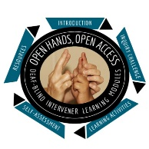
Open Hands, Open Access Deaf-Blind Intervener Learning Modules
Module: An Overview of Deaf-Blindness and Instructional Strategies

Intervener Journal
This journal is a way for you to note ideas or thoughts that you have as you proceed through the module. It also includes some questions that you will be directed to from specific sections of the module.
Before you use this journal, save a copy to your computer or other location.
Name:
Date:

Inquiry Challenge Questions
(You will answer these questions after the Inquiry Challenge and again at the end of the Module. You will also be directed to take some notes about your thoughts as you move through the Module.)
- What might the student’s perspective be about what is going on in this situation?

- What behaviors may be misread by someone who did not understand the student or deaf-blindness?

Revisiting the Inquiry Challenge Questions
(Answer the questions from the Inquiry Challenge again now that you have completed the whole module.)
- What might the student’s perspective be about what is going on in this situation?

- What behaviors may be misread by someone who did not understand the student or deaf-blindness?

- How would you use the knowledge you have gained in this module to help another person better understand the experience of the student in this video?

